Analysis of continuous beam by force method
Input data
Span lengths - $\vec{l}=\left[4;7;3;5\right]·\text{ m}=\left[4\text{ m} 7\text{ m} 3\text{ m} 5\text{ m}\right]$
Number of spans - $n=\text{len}\left(\vec{l}\right)=4$
Coordinates of supports - $\vec{x}=\left[4\text{ m} 11\text{ m} 14\text{ m} 19\text{ m}\right]$
Total beam length - $L={\vec{x}}_{4}=19\text{ m}$
Load - $q=10\frac{\text{ kN}}{\text{ m}}$
Material
Elastic modulus - $E=30\text{ GPa}$
Poisson′s ratio - $ν=0.2$
Shear modulus - $G=\frac{E}{2·\left(1+ν\right)}=\frac{30\text{ GPa}}{2·\left(1+0.2\right)}=12.5\text{ GPa}$
Cross section
Rectangular with dimensions: $b=250\text{ mm}$ , $h=500\text{ mm}$
Area - $A=b·h=250\text{ mm}·500\text{ mm}=125000{\text{ mm}}^{2}$
Moment of inertia - $I=\frac{b·h^{3}}{12}=\frac{250\text{ mm}·{\left(500\text{ mm}\right)}^{3}}{12}=2604166667{\text{ mm}}^{4}$
Shear area - $A_{Q}=\frac{5}{6}·b·h=\frac{5}{6}·250\text{ mm}·500\text{ mm}=104167{\text{ mm}}^{2}$
Solution
The solution will be performed by the force method with a primary system - simply supported beam with internal supports removed and replaced by unknown forces X_{i}
Bending moments
- in section a due to unit force at distance x from the beginning of the beam:
$$M_{1,max}\left(x\right)=\left(\frac{x}{L}-1\right)·x$$
$$M_{1,a}\left(a;x\right)=M_{1,max}\left(x\right)·\left(\{\begin{matrix} if a<x: & \frac{a}{x} \\ else: & \frac{L-a}{L-x}\end{matrix} \right)$$
- in section a, due to unit force X_{i}:
$$M_{1}\left(a;i\right)=M_{1,a}\left(a;{\vec{x}}_{i}\right)$$
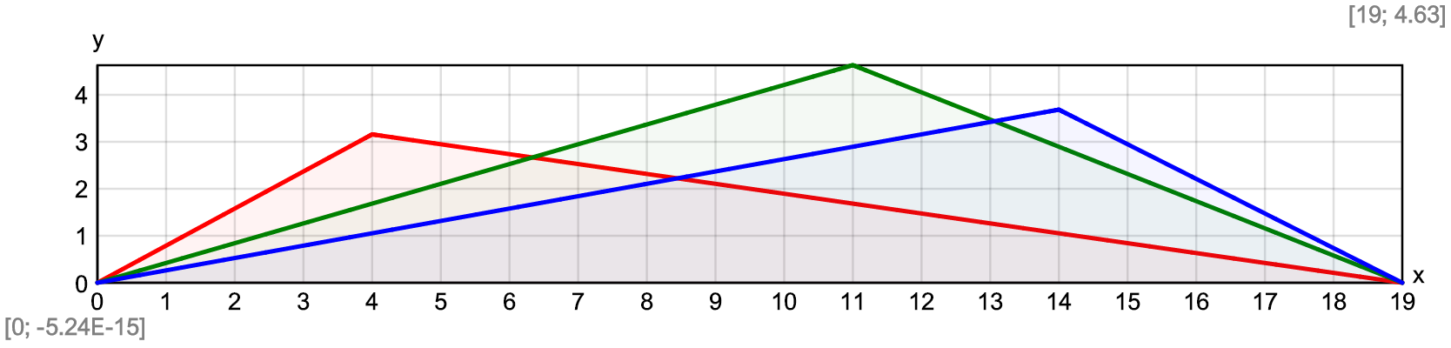
- due to external loads in primary system:
$$M_{F}\left(x\right)=\frac{q·x}{2}·\left(L-x\right)$$
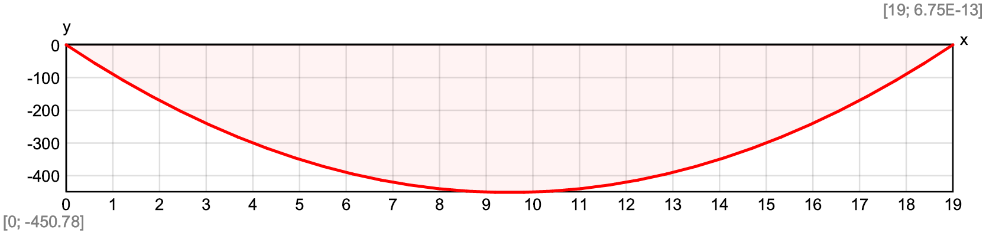
Shear forces
- in section a due to unit force at distance x from the beginning of the beam:
$$V_{1,a}\left(a;x\right)=\{\begin{matrix} if a<x: & \frac{x}{L}-1 \\ else: & \frac{x}{L}\end{matrix}$$
- in section a, due to unit force X_{i}:
$$V_{1}\left(a;i\right)=V_{1,a}\left(a;{\vec{x}}_{i}\right)$$
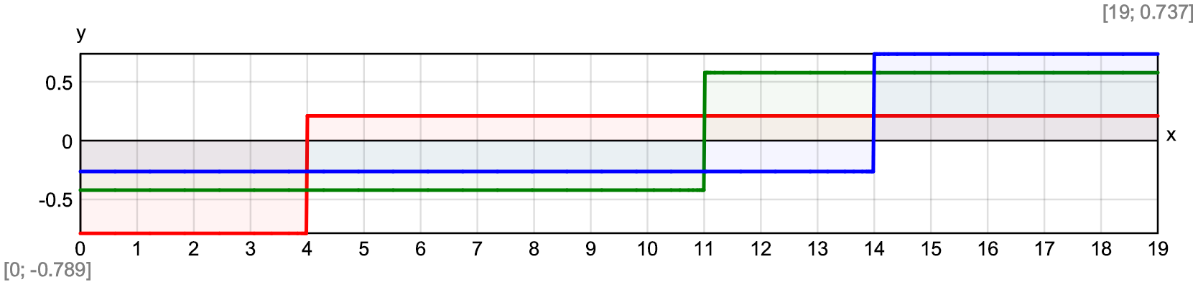
- due to external loads in primary system:
$$V_{F}\left(x\right)=q·\left(\frac{L}{2}-x\right)$$
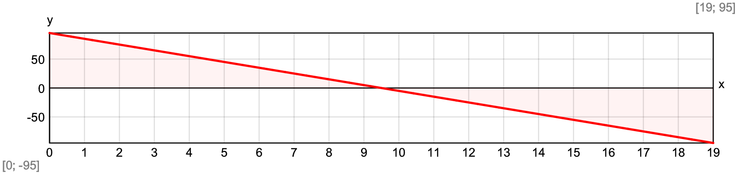
Number of unknowns by force method - $n_{1}=n-1=4-1=3$
Flexibility coefficients
$$δ\left(i;j\right)=\int_{0\text{ m}}^{L}{\frac{M_{1}\left(x;i\right)·M_{1}\left(x;j\right)}{E·I} dx}+\int_{0\text{ m}}^{L}{\frac{V_{1}\left(x;i\right)·V_{1}\left(x;j\right)}{G·A_{Q}} dx}$$
$$Δ_{F}\left(i\right)=\int_{0\text{ m}}^{L}{\frac{M_{1}\left(x;i\right)·M_{F}\left(x\right)}{E·I} dx}+\int_{0\text{ m}}^{L}{\frac{V_{1}\left(x;i\right)·V_{F}\left(x\right)}{G·A_{Q}} dx}$$
$δ=\text{symmetric}\left(n_{1}\right)=\text{symmetric}\left(3\right)=\left[\begin{matrix}0 & 0 & 0 \\ 0 & 0 & 0 \\ 0 & 0 & 0\end{matrix}\right]$ , ${\vec{Δ}}_{F}=\text{vector}\left(n_{1}\right)=\text{vector}\left(3\right)=\left[0 0 0\right]$
$$\$Repeat\left\{\$Repeat\left\{δ_{i,j}=δ\left(i;j\right);i=1...n_{1}\right\};j=1...n_{1}\right\}=0.0011\text{ m}/\text{ kN}$$
$$\$Repeat\left\{{{\vec{Δ}}_{F}}_{.i}=Δ_{F}\left(i\right);i=1...n_{1}\right\}=-0.161\text{ m}$$
$δ=\left[\begin{matrix}0.000811\text{ m}/\text{ kN} & 0.00101\text{ m}/\text{ kN} & 0.000719\text{ m}/\text{ kN} \\ 0.00101\text{ m}/\text{ kN} & 0.00174\text{ m}/\text{ kN} & 0.00133\text{ m}/\text{ kN} \\ 0.000719\text{ m}/\text{ kN} & 0.00133\text{ m}/\text{ kN} & 0.0011\text{ m}/\text{ kN}\end{matrix}\right]$ , ${\vec{Δ}}_{F}=\left[-0.135\text{ m} -0.211\text{ m} -0.161\text{ m}\right]$
Calculation of the unknown forces X_{i}
$$\vec{X}=-\text{clsolve}\left(δ;{\vec{Δ}}_{F}\right)=\left[64.86\text{ kN} 53.48\text{ kN} 39.33\text{ kN}\right]$$
Results
Bending moment diagram - $M\left(x\right)=M_{F}\left(x\right)+\sum_{i=1}^{n_{1}}{M_{1}\left(\vec{x};i\right)·X_{i}}$
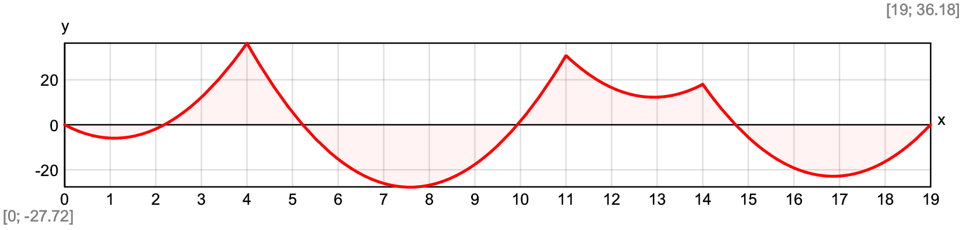
$${\vec{M}}_{max}=\left[5.97\text{ kNm} 27.74\text{ kNm} -12.23\text{ kNm} 22.9\text{ kNm}\right]$$
$${\vec{M}}_{min}=\left[-36.29\text{ kNm} -30.79\text{ kNm} -17.99\text{ kNm}\right]$$
Shear force diagram - $V\left(x\right)=V_{F}\left(x\right)+\sum_{i=1}^{n_{1}}{V_{1}\left(\vec{x};i\right)·{\vec{X}}_{i}}$
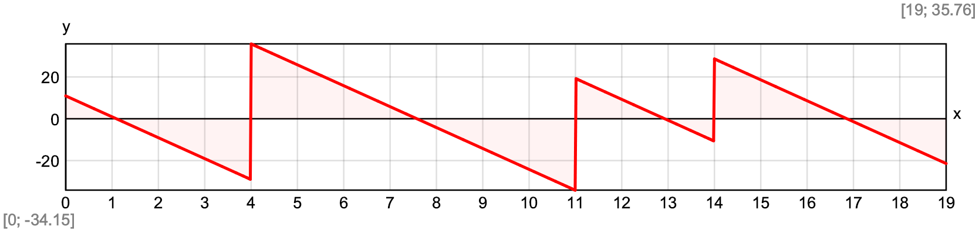
$${\vec{V}}_{max}=\left[10.93\text{ kN} 35.79\text{ kN} 19.26\text{ kN} 28.6\text{ kN}\right]$$
$${\vec{V}}_{min}=\left[-29.07\text{ kN} -34.21\text{ kN} -10.74\text{ kN} -21.4\text{ kN}\right]$$
Deflections
- in section a, due to unit force X_{i}:
$$d_{1}\left(a;i\right)=\int_{0\text{ m}}^{L}{\frac{M_{1,a}\left(x;a\right)·M_{1}\left(x;i\right)}{E·I} dx}+\int_{0\text{ m}}^{L}{\frac{V_{1,a}\left(x;a\right)·V_{1}\left(x;i\right)}{G·A_{Q}} dx}$$
- due to external loads in primary system:
$$d_{F}\left(a\right)=\int_{0\text{ m}}^{L}{\frac{M_{1,a}\left(x;a\right)·M_{F}\left(x\right)}{E·I} dx}+\int_{0\text{ m}}^{L}{\frac{V_{1,a}\left(x;a\right)·V_{F}\left(x\right)}{G·A_{Q}} dx}$$
$$d\left(x\right)=d_{F}\left(x\right)+\sum_{i=1}^{n_{1}}{d_{1}\left(\vec{x};i\right)·{\vec{X}}_{i}}$$
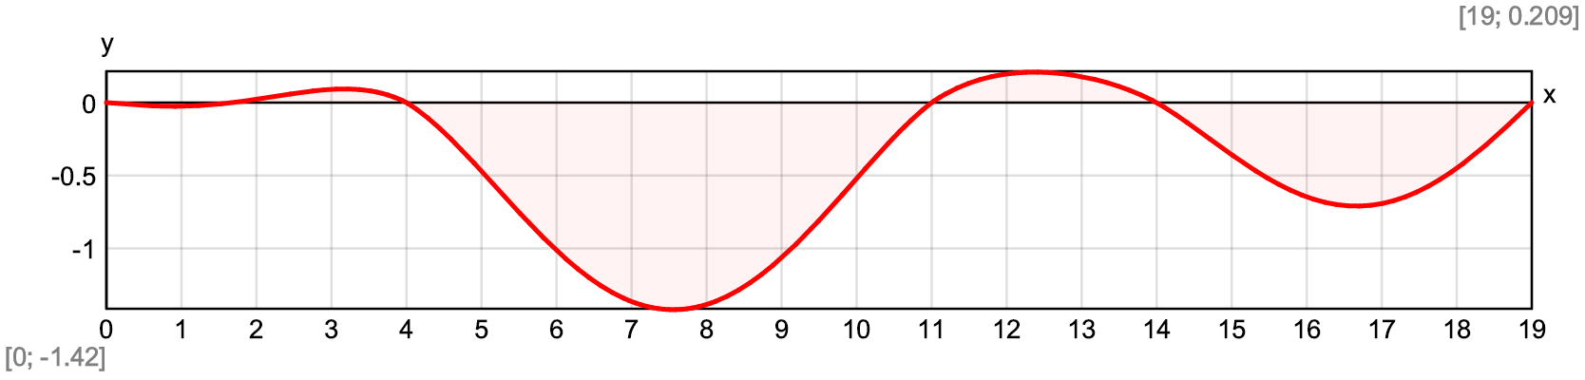
Maximum deflection - $d_{max}=\$Inf\left\{d\left(x\right);x∈\left[0\text{ m};L\right]\right\}=-1.42\text{ mm}$
At a distance from the origin - $x_{inf}=7.56\text{ m}$

Comparison with Stadyps 6.0 structural analysis software
Loads and support reactions, kN 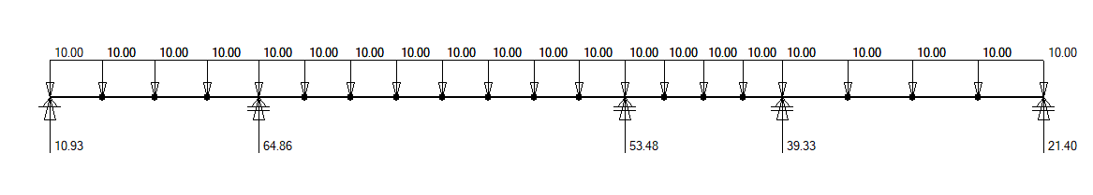
Bending moments, kNm
Shear forces, kN
Deflections, mm
